Loaves and Fishes Event, June 5, 2014
"Feeding the Hungry" was not just the theme for our annual Synod Assembly - it was also the service project!

Along with a few friends and guests, more than 900 Lower Susquehanna Synod Lutherans packaged more than 300,000 meals destined for dinner plates of our needy neighbors here in central Pennsylvania. The daylong service project provided an exciting kickoff to our annual assembly, which concluded Saturday at Messiah College in Grantham.

Working from 7 a.m. to 7 p.m., volunteers packaged 300,324 meals from bulk shipments of rice, beans, vegetable protein, dried vegetables and seasonings. Enough of each ingredient to
Celebrating a job well-done.
provide a meal for a family of four was measured and sealed in a plastic bag. The meals are not only nutritionally balanced but also easy to prepare - just pour the contents into boiling water.

"The ELCA is a church that does God's work with our hands," said Bishop James Dunlop, "and this is an opportunity for us to come together and to use our hands to really feed those who hunger in our communities."

To pull off the event, our synod partnered with Thrivent Financial, Messiah College, and End Hunger NE (Outreach, Inc.). A hearty thank-you goes to these three entities for helping with everything from pre-event logistics, support, and resources, to donated space, to clean-up after the event. Rick Baldwin of Thrivent and Matthew Martin of End Hunger NE worked tirelessly before, during, and after the event to ensure that this mammoth undertaking was a success.

The food will be distributed by the Central Pennsylvania Food Bank. Money to pay for the $75,000 came from congregations and generous contributors (donations are still being accepted).

This hands-on service project provided a positive kickoff to our annual Synod Assembly, which this year focused on how the church feeds people's deepest hungers - not only for food but also for belonging, for love, for community and for spirituality. The gathering of about 1,000 people learned about the many ways Lutherans care for others in nine counties of south central Pennsylvania.

A "Ministry Minute" video showed how Lutheran Church of the Holy Trinity in Lancaster not only offers a free weekly breakfast to anyone who drops in, but also runs programs that provide shoes for needy youth, that offer bicycle repairs to those who don't have cars, that match city kids with police officers who help them shop for Christmas gifts.

Another video explained how volunteers of St. Matthew in Hanover prepare backpacks full of food for needy schoolchildren to take home every weekend to tide them over.

Pastor Reumann encouraged those at Synod Assembly to take action by writing paper plate letters to their state legislators.
The Bible study leader, the Rev. Amy Reumann of Lutheran Advocacy Ministries of Pennsylvania, spoke of God's concern for the neediest among us, and how God expects faithful people to care for the needy, as well. Dan Rift, director of ELCA World Hunger, delivered an interactive and thought-provoking keynote address.

Of course, people hunger for more than just food, but also for community, connection to God, spirituality and meaning.

"People are hungry for the work of the church, and where the hungry are fed is where the Lower Susquehanna Synod is," said Bishop Dunlop.

Note: It's not too late to participate by donating to offset the cost of the event! So far some 110 of our synod's congregations have provided financial support. Others sent volunteers. If you'd like to help us move closer to 100% participation, please send your gift of any amount to: Lower Susquehanna Synod Treasurer's Office, 900 S. Arlington Avenue, Suite 220B, Harrisburg, PA 17109. Mark your donation "Loaves and Fishes." Thank you!

Ordinations & Consecration Among Assembly Highlights

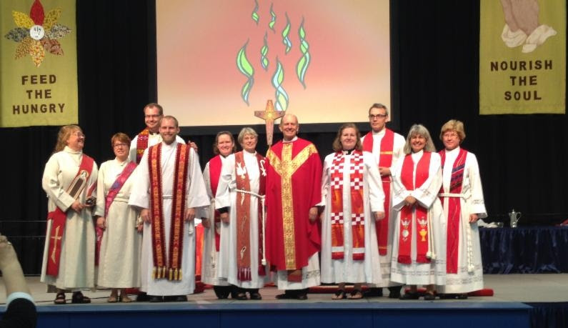

This year Assembly attendees and guests were able to worship and celebrate the ordinations and consecration of five new rostered leaders. Consecrated as a Deaconess was Sister Dottie Almoney (called to St. Peter's, Neffsville). Ordained as pastors were Laura Haupt (called to St. James, Gettysburg), Nancy Knol (called to St. John, Barner's), Ursula Schreffler (called to Zion, Union Deposit), and Ben Siebert (called to Trinity, Arendtsville). David Sensenig (called to Good Shepherd, Liverpool) received orders for training as a Reserve Navy Chaplain and was unable to be present at Assembly. He will be ordained on July 20, at 6:30 p.m. at Christ Lutheran in Linglestown.

Want to watch the live-stream recordings (six sessions) from Synod Assembly? Click here to be redirected to our Ustream Channel. The video will be available here in high-definition until July 4, 2014. You will also find highlights posted to our synod YouTube channel.

Note: Post-assembly information and resources are now posted here on our synod's website. You will find an order form for a hard copy of the 2014 Preliminary Minutes (the 2014 Preliminary Minutes will be available online), an order form for a synod handbook and directory (minute book), a Digest of Synod Assembly Actions (including adopted Resolutions) and an Assembly Wrap-Up Bulletin Insert.

